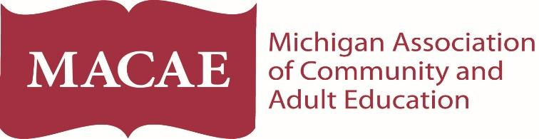
MACAE 2018 Spring Institute
Thursday, May 17, 2018 Alternative Education Focus 8:30 a.m. - 4:00 p.m.

- Unmasking At-Risk Youth, Trauma Awareness
- Anxiety and Panic Attacks
- Early Warning Systems, Alternative Accountability
- MDE Parent Portal Dashboard

PRESENTERS: Michigan Department of Education, Sheila Brown, Michelle Robydek, Lisa Lark

Friday, May 18, 2018 Adult Education Focus 9:00 a.m. - 3:00 p.m.

State Update, Program Services Overview, What to Expect for 2018-19

PRESENTERS: Krista Johnson, Joe Billig, Sandy Thelen, Sue Muzillo, Brian Frazier & other Adult Ed Staff

Michigan State University Henry Center
3535 Forest Road, Lansing 48910
Overnight rooms are available at the Candlewood Suites, which is attached to the Henry Center. The group rate is $75/night. For reservations, please call (517) 351-8181. Use code MAC.
Cost for the workshop:
Thanks to the support of the Michigan Talent Investment Agency we are able to offer the MACAE member rate to providers who receive Section 107 or WIOA funds. Includes continental breakfast, lunch and snack.

May 17th: $60 for MACAE members__________ $90 non-members_________
May 18th: $60 for MACAE members/providers who receive Section 107 or WIOA funds_________
$90 non-members_________
Both days: $110 for MACAE members/providers who receive Section 107 or WIOA funds________
$170 non-members________
Total $_______

To register via credit card, please visit www.macae.org or email your form to macaeoffice@gmail.com or fax to (517) 492-1368.
For questions about registering, please call (517) 492-1367
Name School/Organization

Additional Participants Address with city and Zip Code

Phone Email

Payment Type: ___ Invoice/Check ___ Credit Card (please go to www.macae.org)

